Date:

EDO REQUEST

|  |  |
| --- | --- |
| To : | ONE TEAM EXPRESS (PVT) LTD |
| BL numbers:  Cnee Details : |  | |
| Vessel & ETA Colombo: |  | |

We hereby request you to send the e-Delivery Order of the above mentioned import shipments, to the email address: [imports@oneteamexpress.com](mailto:imports@oneteamexpress.com)

In consideration of your complying with our above request, we hereby agree to indemnify

you/owners, your agents, servants, contractors and sub-contractors and to hold all of you harmless in respect of any and all liability, loss, damage or expense of whatsoever nature and howsoever caused including, but not limited to, loss or damages, and/or other parties which you sustain by reason of the above cargo in accordance with our request.

Yours faithfully,

…………………..

Signature

Name:

Designation:

Contact Details:

Dear Valued Customer,

**ELECTRONIC DELIVERY ORDER ISSUANCE**

**ONE TEAM EXPRESS** who has been striving continuously to evolve with the changing demands, taking in to consideration the present situation is pleased to introduce the E-DO facility in order to facilitate the trade while ensuring the social distancing requirements amid COVID 19 threat, **ONE TEAM EXPRESS** is ready to issue your delivery orders on line (E-DO).

The procedure to obtain E-DO is as follows.

➢ If Original BL(or Bank Guarantee) is in customer’s hold, customer should hand over the duly endorsed original BL( or Bank Guarantee upon origin approval) + the original FCL guarantee letter (if FCL) + E-DO request + ID copy + payment proof ,to the documents accepting desk at **ONE TEAM EXPRESS**.

➢ If Original BLs have been surrendered at the port of loading (Telex release) or Seaway (Express Release), customer should email the scanned FCL guarantee letter (if FCL) + E-DO request + ID copy + payment proof, to **ONE TEAM EXPRESS**.

➢ For the Delivery Order Payments & the other payments, we’ll accept **ON LINE TRANSFERS ONLY,** till further noticed due to our cashier counter will be closed with effect from 18.10.2020 for the customers

In order to complete the transaction immediately, we recommend using CEFT transfer method. After the successful payment transfer, kindly send us the transaction details via email.

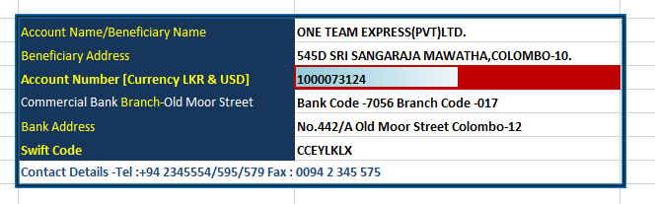

In your Transaction, **“B/L NUMBER OR INVOICE NUNMBER “MUST** mention under beneficiary Remarks, otherwise it may result delays to serve you on time.

E-DO requests should be sent to the imports@oneteamexpress.com, with the subject of **“E-DO REQUEST B/L NO ………………………….”** With coping to the accounts@oneteamexpress.com

**WORKING HOURS WEEK DAYS 9.00 AM TO 4.00 PM ONLY**